Hall ticket number | 0425046037
Name of the student | SELVARAJ YASWINI
Learning track | Data analytics with tableau

ASSIGNMENT
Area chart:
1.open tableau and create a new sheet.
2. drag order date to the columns.
3.change year (order date) to month.
4.drag quantity to the rows.
5.drag ship mode to the color.
6.click the chart type option in the marks card.
Output:
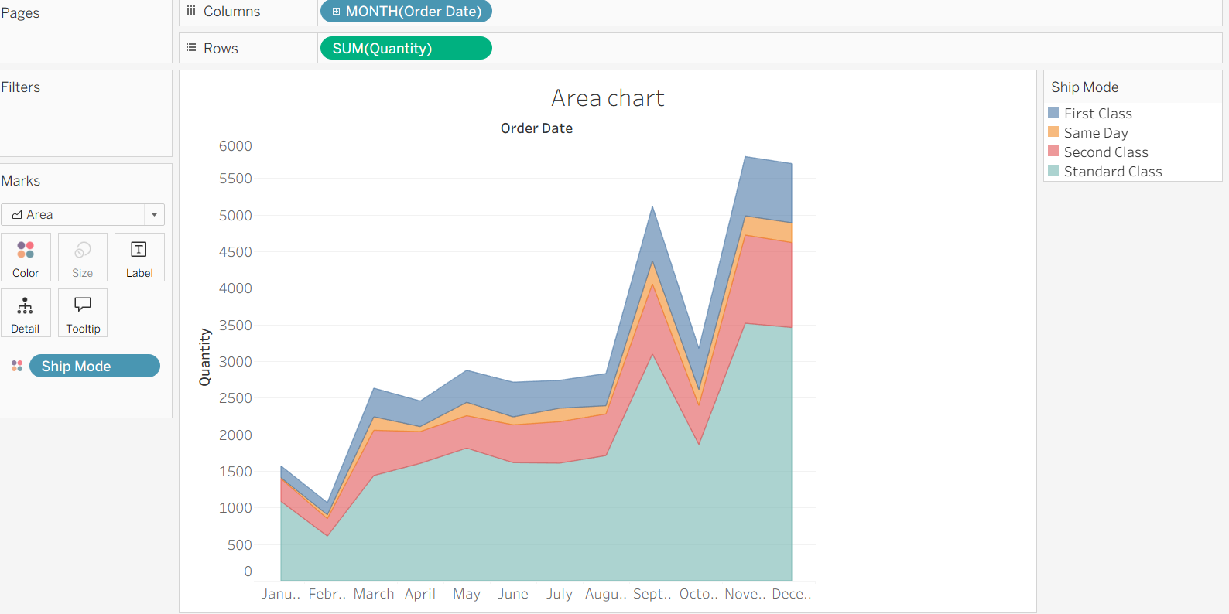

Bar chart:
- Drag sales to the rows shelf.
- Click the drop- down menu in the marks card.
- Select bar chart.
- Drag ship mode to color.
- Drag region to the region to the left side of sales in rows.
- Drag region again to filters.
- Select only west region in the filter box ,click ok.
Output:
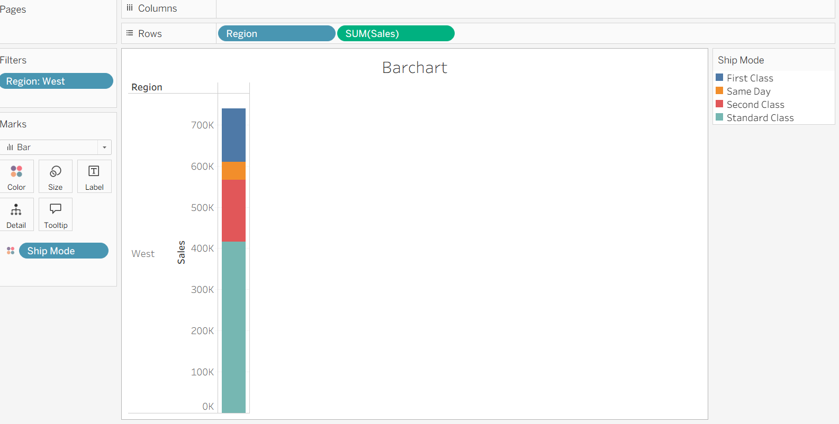

BOX PLOT
- Drag segment to columns shelf.
- Drag discount to rows shelf.
- Right click on discount change it from sum to average.
- Drag region to columns shelf. (it will be placed on the right side of the segment).
- Click show me and select box-and whisker plot.
- Go to the analysis menu, turn off aggregate measures.
- click swap rows and columns button.
Output:
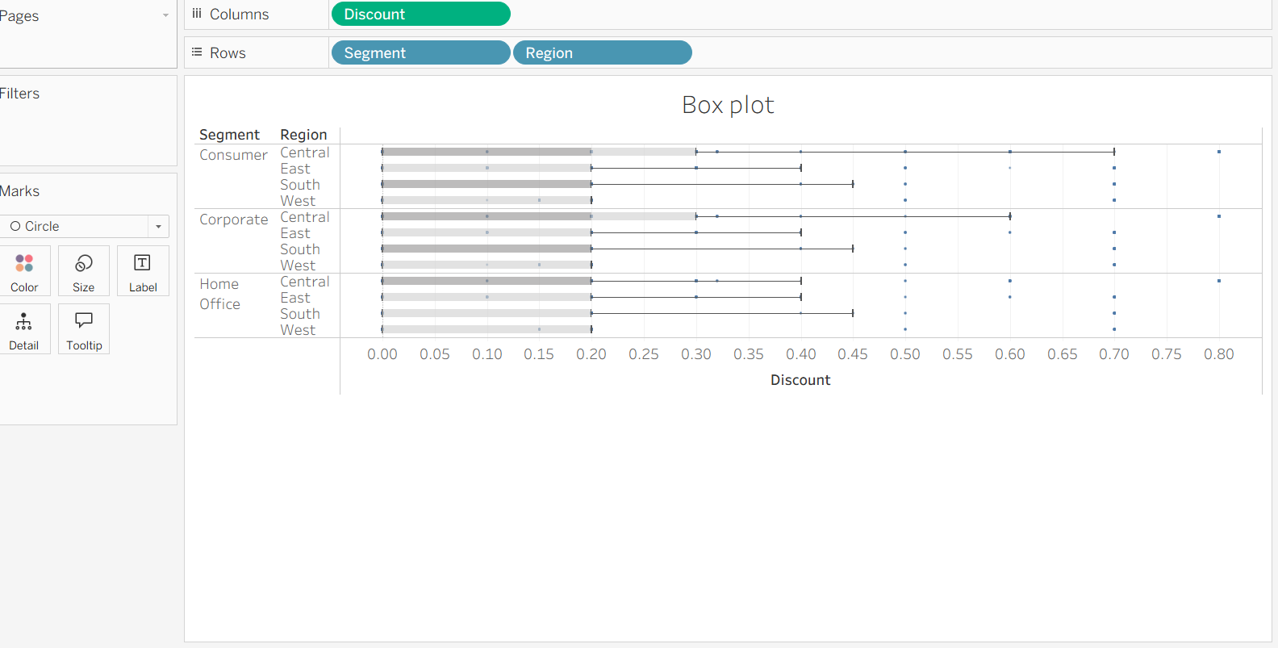

GANTT CHART:
- Drag order date to columns.
- Click drop down arrow on year (order date) in columns
- Then select week number.
- Drag sub category to the rows shelf.
- Drag ship mode to the rows in the right side of the sub category.
- Go to the marks card drop down menu, select ganttbar.
- Click analysis menu
- Create calculated field, the dialog box will appear.
- Now the type the name – Order Until Ship.
- Formula: DATEDIFF (‘day’, [Order Date], [Ship Date]) click ok.
- Drag your new order until ship on to size in the marks card.
- Right-click sum (order until ship) on the marks card.
- Choose measure, select average from the list.
- Drag ship mode on to color in the marks card.
Output:

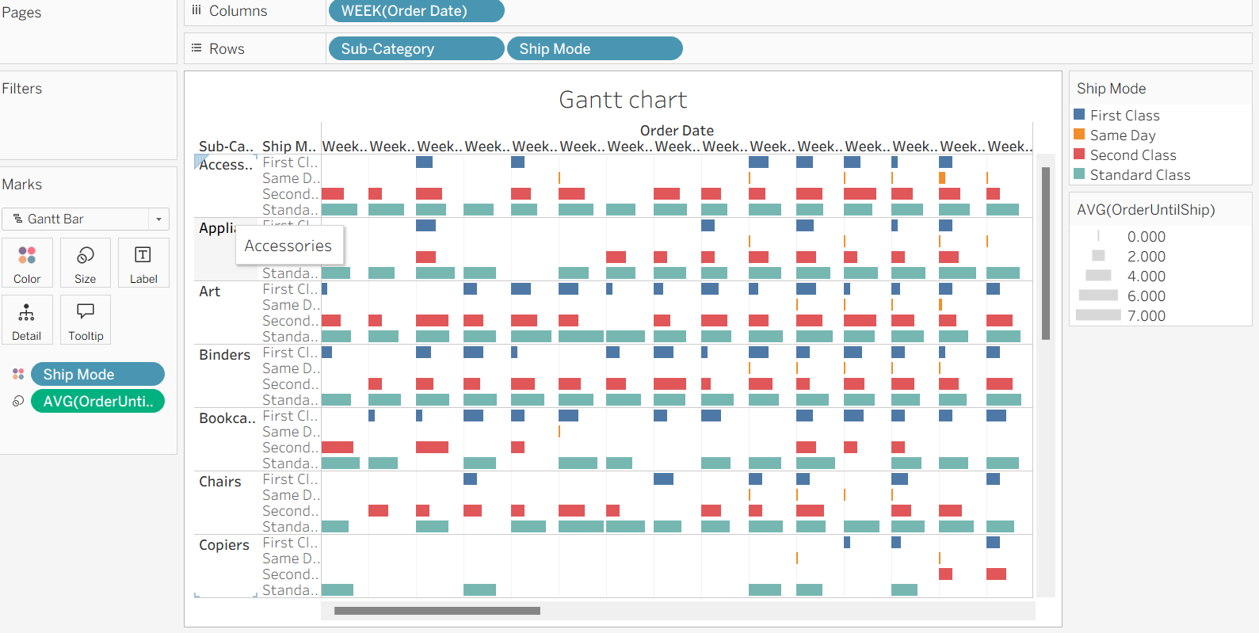

HEATMAP
- Drag segment to columns.
- Drag region to rows shelf.
- Drag sub-category on the right side of region in the rows shelf.
- Drag profit to color in the marks card.
- Go to the marks card, click on color.
- Go to the border, select gray color.
- Click profit color arrow, select edit colors.
- Choose red-black -diverging, tick use full color range then click apply and ok.
- Drag sales size in marks card.
- Click size in marks card.
- Move the slider to right, the boxes get bigger.
Output:
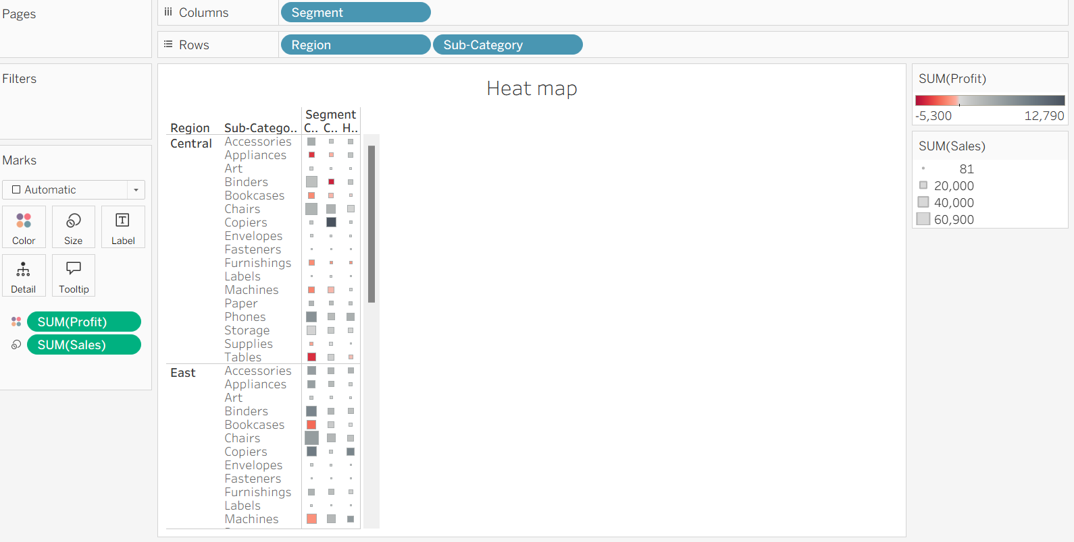

HISTOGRAM:
- Drag quantity to columns shelf.
- Click show me (it is place on the right of the corner).
- Select histogram.
- Creates the histogram automatically.
- Drag segment to color.
- Press control, drag CNT (quantity) from rows to label.
- Right click CNT quantity on label, choose quick table calculation from menu
- Select the percent of total option.
Output:
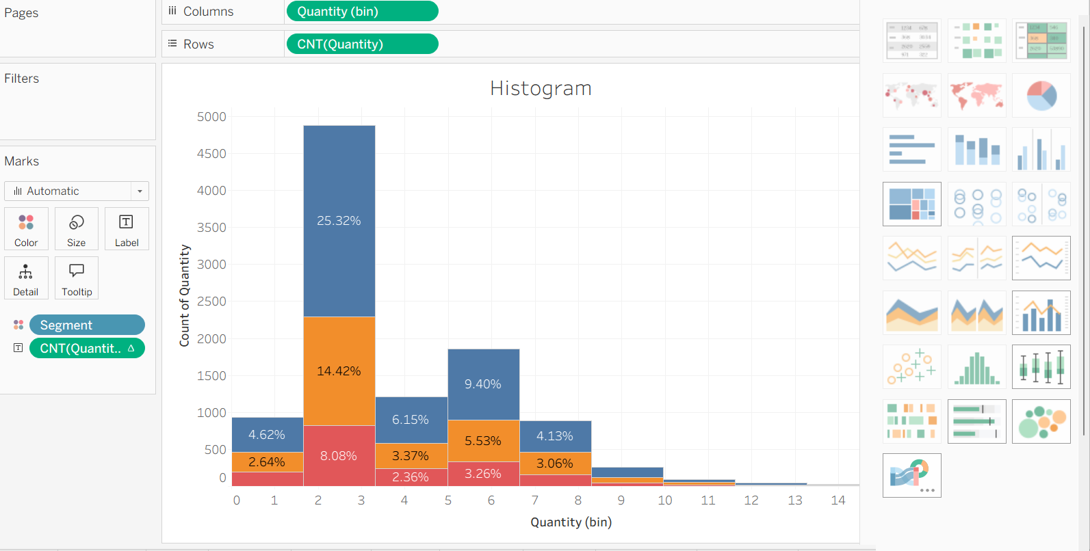

LINE CHART
- Drag ship date to columns shelf, it shows the year ship(date).
- Drag sales to rows shelf
- Add profit to the rows shelf it will be placed to be right side of the sales.
- Drag sum(profit) onto the sales axis.
- Click drop down arrow on year (ship date), select month.
- We can see sales and profit changes.
- Open analytics pane.
- Drag forecast and place it on the chart.
Output:
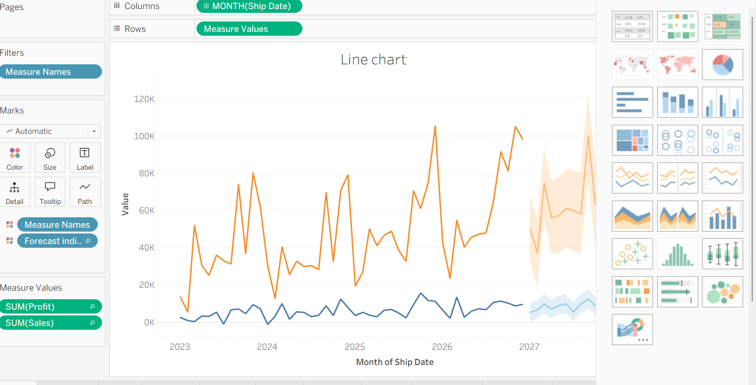

BUBBLE CHART
- Drag category from columns shelf.
- Drag sales to the rows shelf.
- Click show me it is placed on the right side of the top.
- Select bubble chart.
- Drag region, it is placed it on detail.
- Drag profit, it is placed it on color.
- Take the region again, drop it on label.
Output:
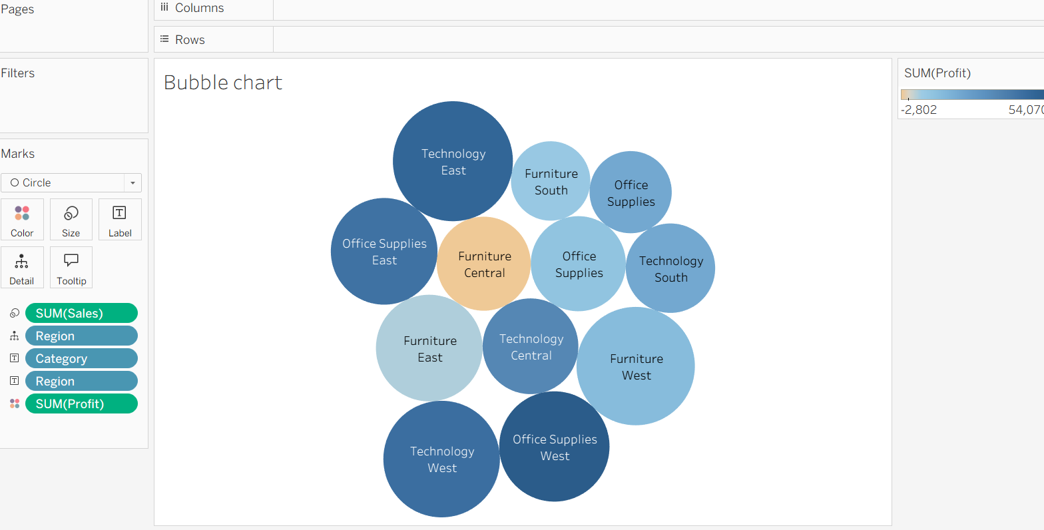

PIECHART:
- drag profit to columns shelf.
- Drag category to rows shelf.
- Click show me in the top-right corner, select pie chart.
- click fit on the top toolbar, choose enter view.
- click size, then drag the slider right to make the pie chart bigger.
- Drag category and drop it on the label.

Output:
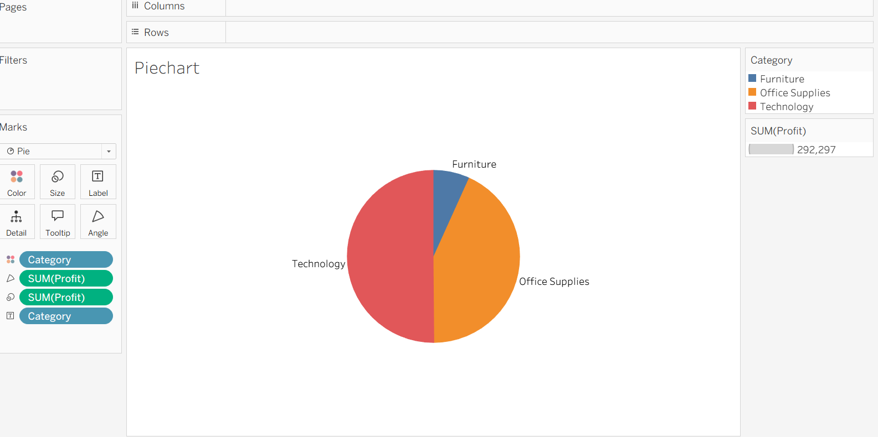

SCATTERPLOT:
- Add sales to columns.
- Add profit to rows.
- Add category to color.
- Add region to detail.
- Click analysis, then drag trend line to the chart.
Output:
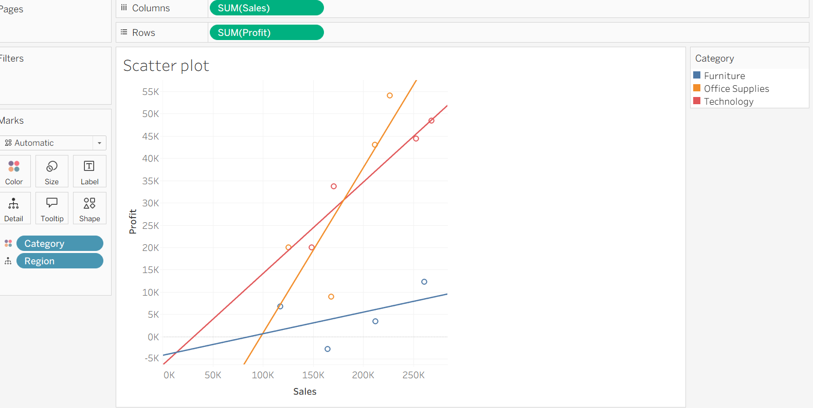

TEXT TABLE WITH PERCENTAGES
- Drag order date to columns shelf.
- Drag sub category to rows shelf.
- Drag sales to put it on text in marks card.
- Drag region and place it left side of the sub category.
- Right click on sum(sales) and select add table calculation.
- Then select percental of total.
- In compute using, select pane(down).
- Click ok.
Output:
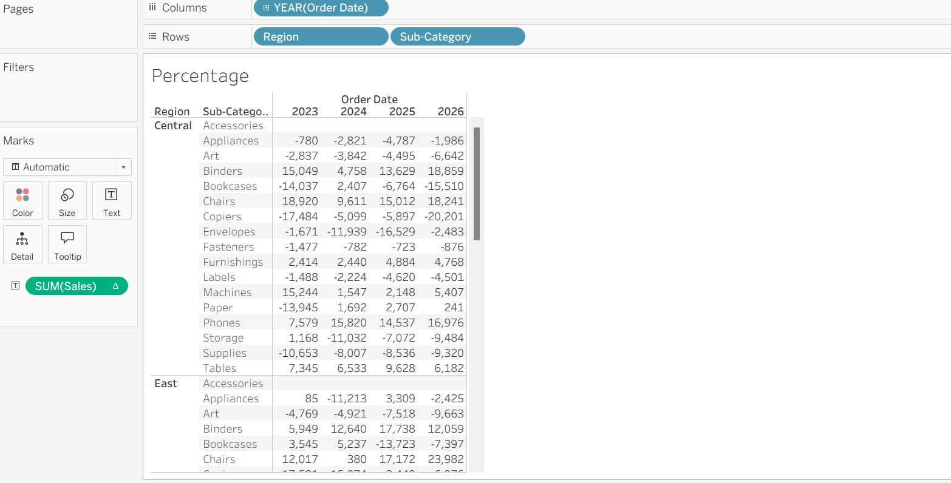

TREE MAP:
- Drag sub category and place it in columns shelf.
- Drag sales and place it in rows shelf.
- Click show me and select tree map.
- Drag ship mode and place it on color.
- If you want profit color, remove ship mode.
- Drag profit and place it on color.
Output:
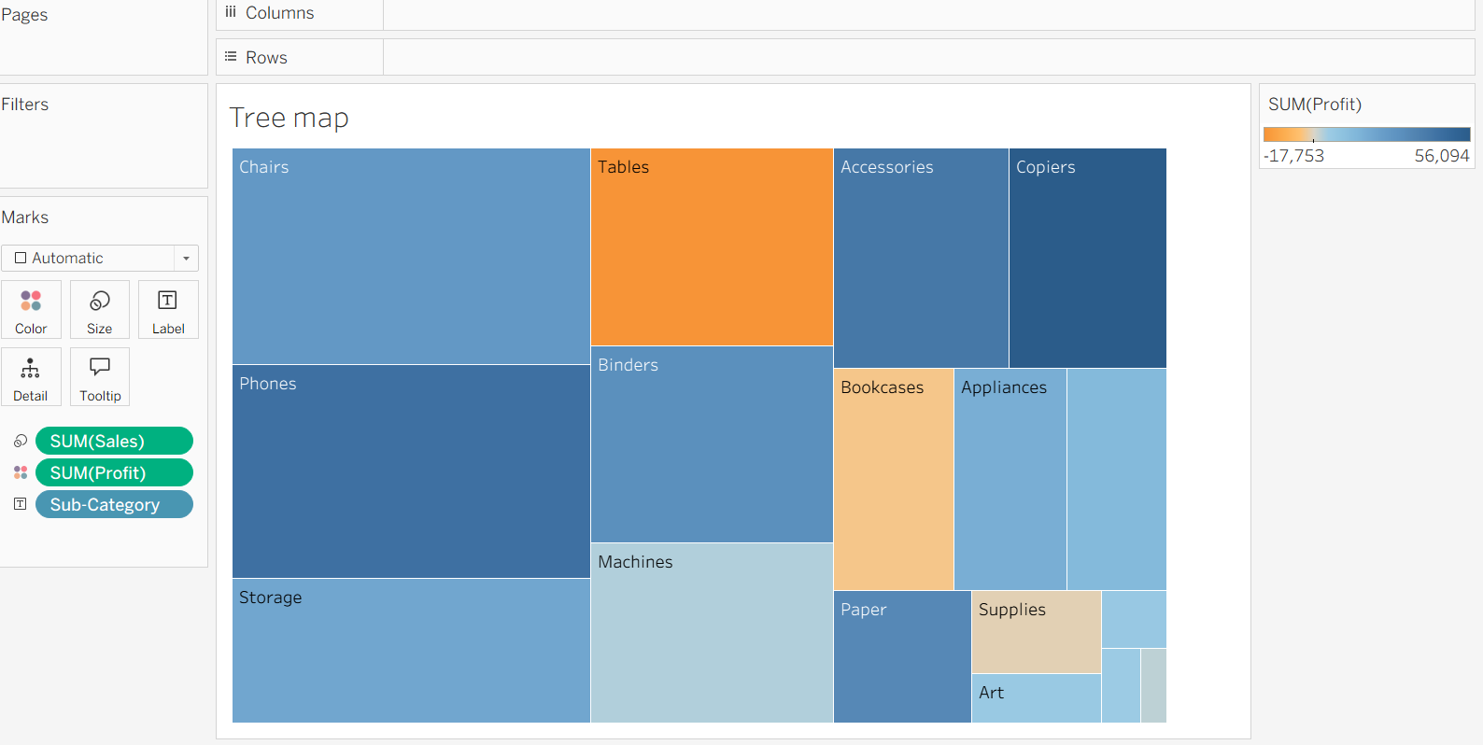

DONUT CHART:
- Go to the analysis menu.
- Select the create calculate field.
- Type name Zero, in the formula box type 0 click ok.
- Drag zero into the rows shelf.
- In the marks card, select pie chart.
- Again, drag zero into the rows shelf.
- Place it on the right side of the first sum(zero).
- Select dual axis.
- Click the second sum(zero)
- Click size, make the size small.
- Click color, select white.
- Click first sum(zero), drag region to the color.
- Again, drag region to the label.
- Drag sales to the label.
- Drag sales to the angle.
- Then click the second sum(zero) in marks card.
- Add sales to label.
- Click label .
- Click (…) type total sales
- Click ok.
Output:
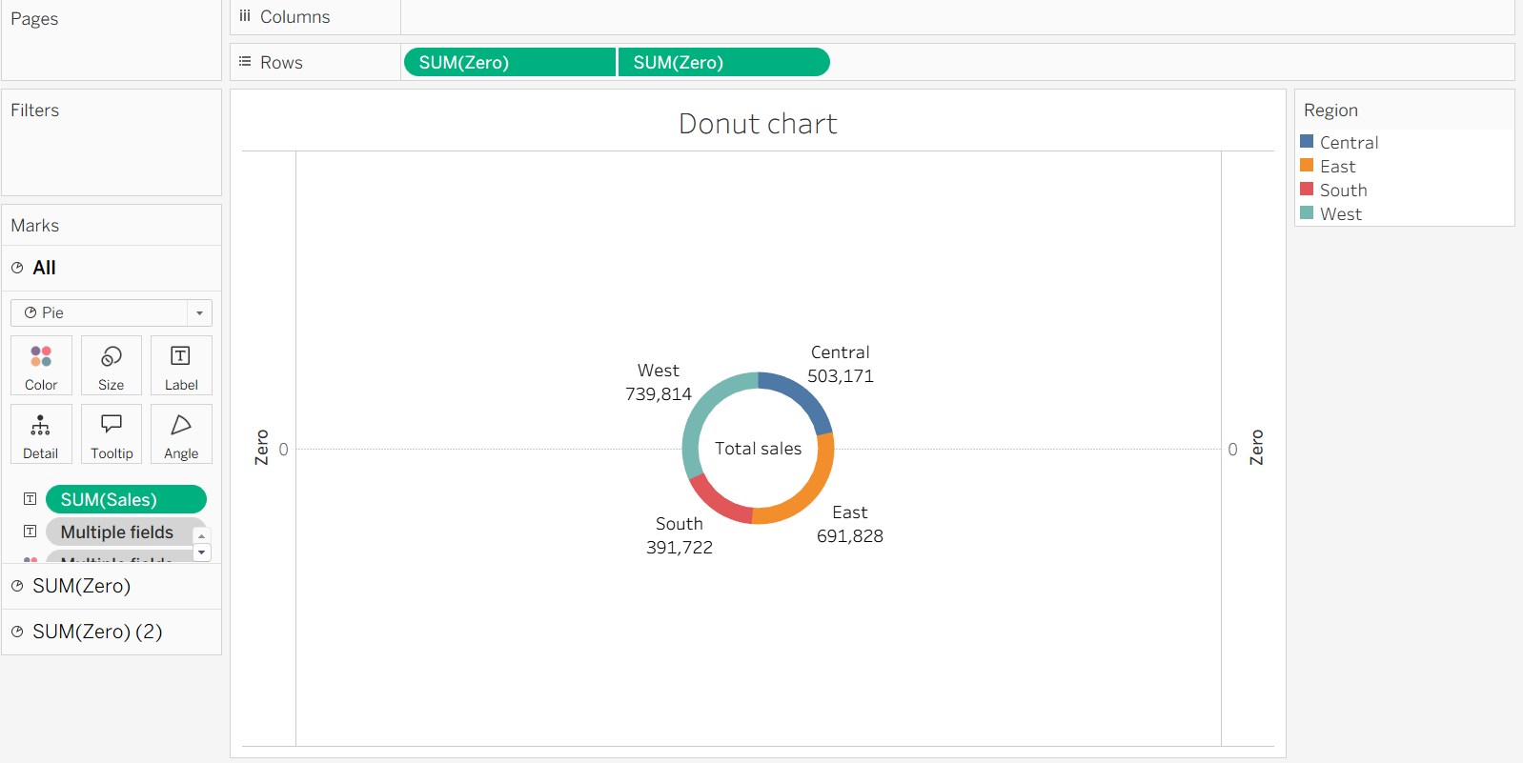

Map chart
- Drag country/region into the detail.
- Drag the state/province into the label.
- Click on the marks card, select map option.
- Drag sales into the colors.
Output:
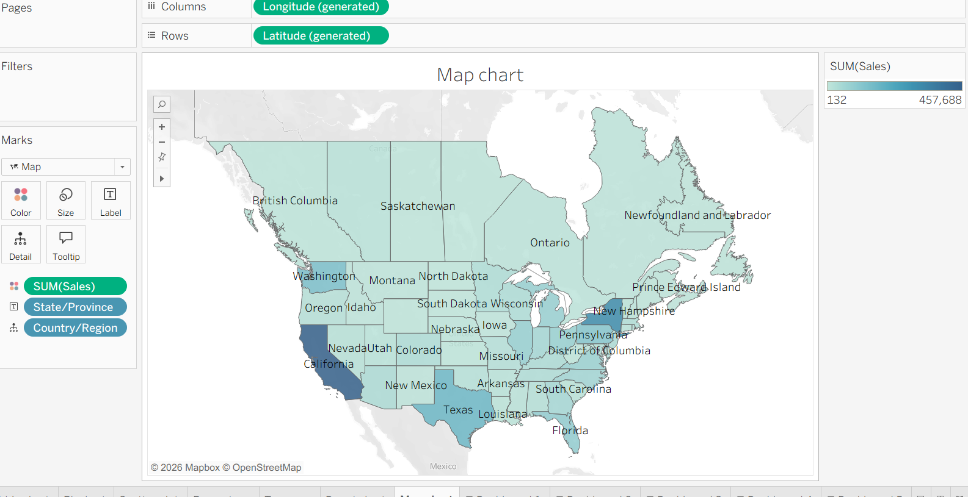

DASHBOARDS:
Dash board 1:

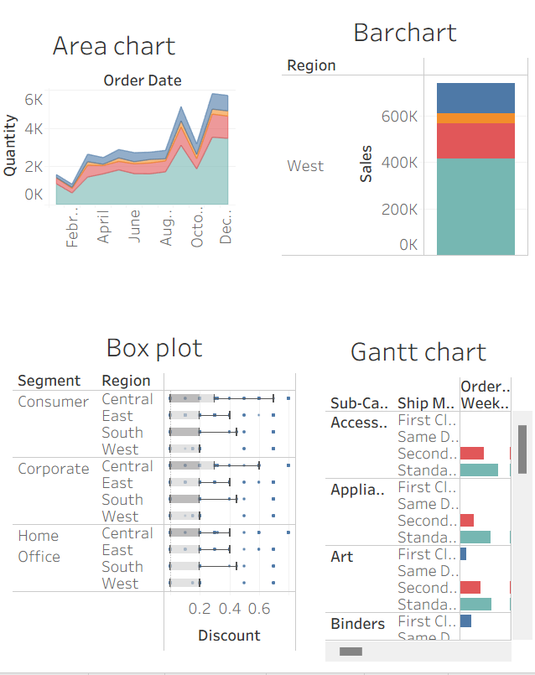

Dash board-2:
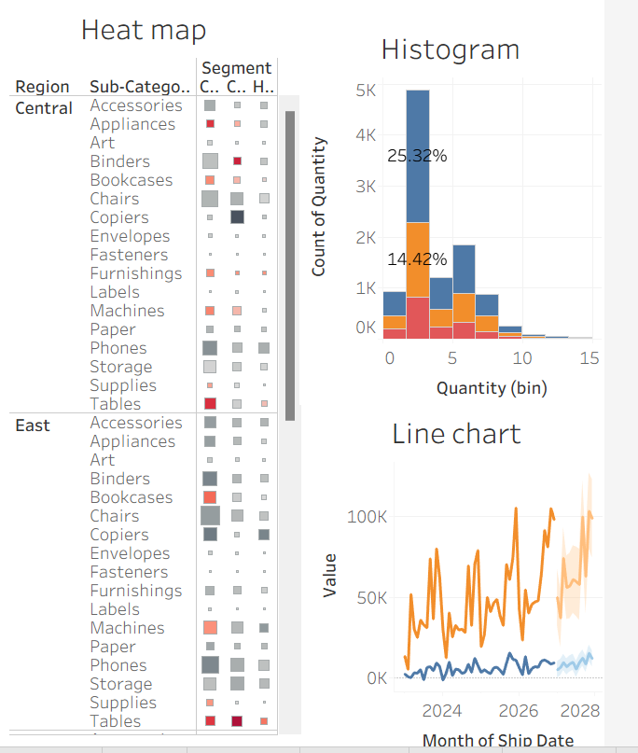
Dashboard3:
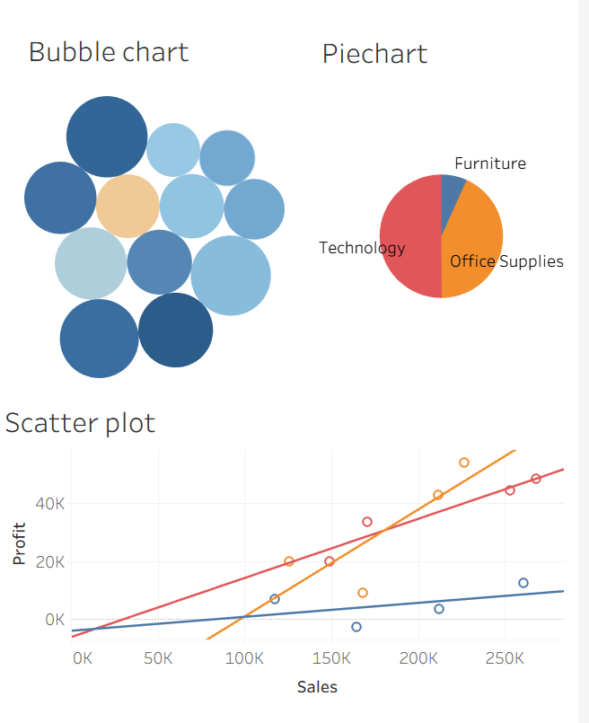
Dash board4:
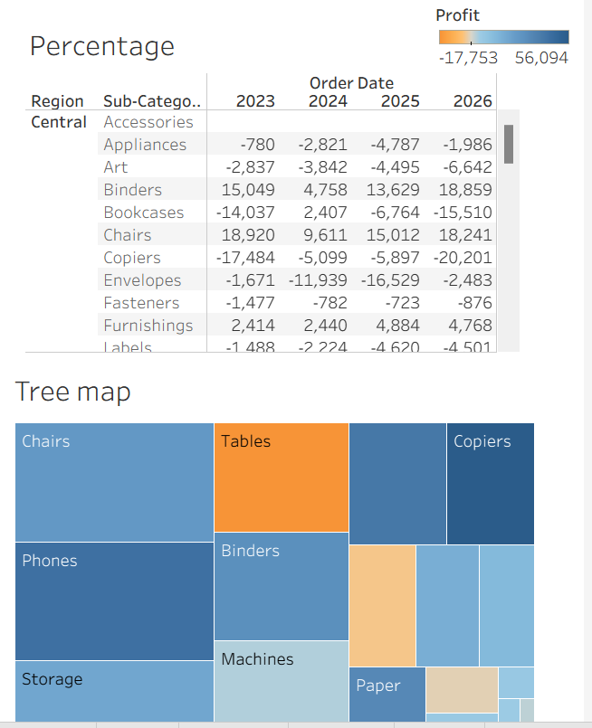

Dash board 5:
